# **Math Symbols**

△ to be used in maths for triangles.

− minus sign for normal text use without equation. Eg 2 − 2 = 0

∕ division sign for normal text use with out equation. Eg 1∕2 = 0.5 Note: the division sign is not the same as the slash sign /. Note the difference between the two.

Δ delta symbol for chemistry. This one has the max probability for error since it looks exactly like the increment symbol from equations. Do not use delta triangle shape for triangles.

≪ ≫ much greater than and less than. Don’t use two >> like this.

℉ ℃ - degree Fahrenheit and degree Celsius symbol. Can be used in equation and in normal text. Eg. 25℃ or $25℃$. Note: if the symbol is used correctly, the cursor will jump the degree symbol and the C together.

° degree symbol. Shot cut command is alt + 0176

∶ ratio symbol. Note it can be inserted from equations under Geometry and not by pressing semi colon symbol on keyboard.

Vulgar fractions can be used from symbols list if not to be inserted as equations. They can be found as under:

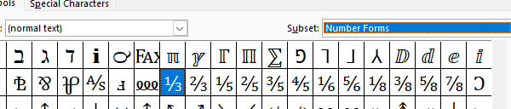

These are used for representations of non math fractions. Eg. Use a ½ cup of water with ⅔ spoon of sugar.

These are all the basic symbols used for the books. Specially for maths books find all the symbols from either in the equations options 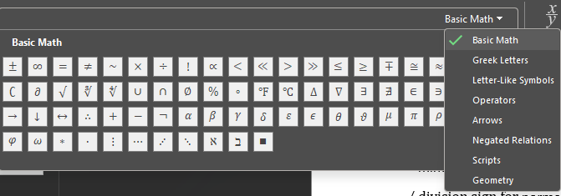

Or from the symbol options 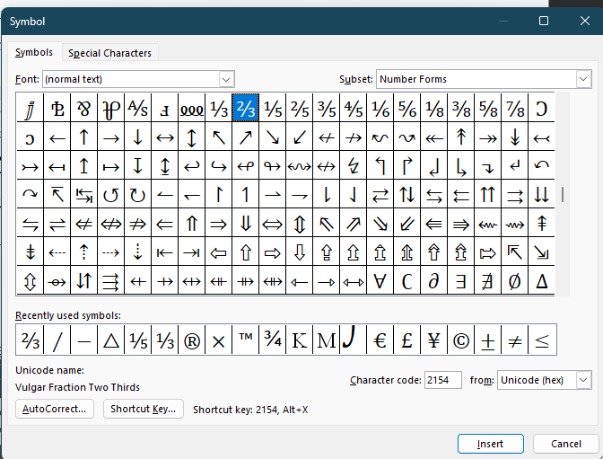

Give more priority to equation option symbols since their ascii values are recognised by NVDA and will read the proper name. Not all symbols in the symbol options have the proper name thus NVDA will read out only the ascii value of the symbol. Always confirm if NVDA is reading the value properly before using it.

Common errors due to similar looking symbols: (hear with NVDA to know the difference)

∆ increment Δ ,delta △ triangle

− minus sign - dash

/ slash ∕division slash

x lettṇer X and × multiply sign

25℃ symbol and °C degree Celsius as simple text which will read degree C.

∶ ratio symbol from equations and : semi colon